Functional & Numerical responses of New Zealands invasive species

Anthony Davidson

13 August, 2018

Table of Contents

Title: 1

Target Journal: 1

Abstract 1

Keywords 1

Introduction 1

Population dynamics are a key tool for the management of ecosystems. 1

*Why? 1

*Direct impact 1

The functional response = each predator increased its consumption rate when exposed to a higher prey density, 1

The numerical response = predator density increased with increasing prey density. 1

The reasons for a meta-analysis now? 1

Objectives 1

Outputs: 1

Scope 1

Methods 1

Key words 1

Additional options 1

Search patterns 1

The data 1

Results 1

Key references: Introduced/invasive predators 1

Choquent and Ruscoe 2000 1

Ruscoe et al. 2005 1

Holland et al. 2015 1

Ruscoe et al. 2005 1

Functional responses 1

Model simulations 1

Numerical responses 1

N1 $rmice =β0$ 1

N2 $rmice =β0+β1(Seed)$ 1

N3 $rmice =β0+β1(Seed)+β2(Density)$ 1

N4 $rmice =β0+β1(Seed)+β2(Density)+β3(Rats)$ Seed driven, density limited and competition (rats). 1

Discussion 1

References 1

Appendix 1

# Title:

Functional & Numerical responses

# Target Journal:

NZ Marine and Freshwater, + other outlets are more important. Goverment groups, universities etc

# Abstract

New Zealand beech forests exhibit boom-bust dynamics. Where, beech trees mast in spatial synchronised but annually variable years dependant. Mice populations have invaded these systems and studies have shown that populations response numerically to changes in resources (beech seed), population density (mice), predator abundance (stoats) and other rodent species (rats). Mice may also exhibit a number of possible functional responses to food, i.e Rmax.

# Keywords

# Introduction

### Population dynamics are a key tool for the management of ecosystems.

### *Why?

### *Direct impact

Holling (1959) studied predation of small mammals on pine sawflies. He observed that predation rates increased with increasing prey population density. He proposed that this phonoomen would arise under two conditions:

The difference between numerical and functional responses

The difference between numerical and functional responses

I started this thinking that these models are the best test of mice dynamics by exhibiting the following possible numerical responses in the wild: $r_{mice} =β_{0}$- Intercept only model. $r_{mice} =β_{0}+β_{1}(Seed)$- Seed driven dynamics. $r_{mice} =β_{0}+β_{1}(Seed)+β_{2}(Density)$- Seed and density dependant effects. $r_{mice} =β_{0}+β_{1}(Seed)+β_{2}(Density)+β_{3}(Rats)$- seed driven, density limited and competition (rats).

This is not the case, the following litrature review was conducted and produced the following database of plausable numerical responses and references.

### The functional response = each predator increased its consumption rate when exposed to a higher prey density,

## [,1]  
## [1,] 0.00000  
## [2,] 0.00139  
## [3,] 0.00278  
## [4,] 0.00417  
## [5,] 0.00556  
## [6,] 0.00695

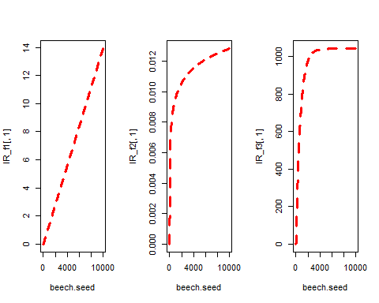

### The numerical response = predator density increased with increasing prey density.

### The reasons for a meta-analysis now?

*Clear the air

*There are many different papers out there with numerical/functional responses scattered throughout different publications, goverment documents and universities throughout NZ.

*Important to know how to apply what we know about theory into the field.

*By consolidating all of these resources into a interactive package commnuity groups, goverment groups and universities can all build on the knowledge we already know collectively.

### Objectives

The objective of this report is to reproduce a comprehensive set of numerical and functional relationships small mammal dynamics. With a focus on house mice (muscus mus mus).

### Outputs:

This analysis has a two fold benefit. 1. By using a reproducable meta-analysis framework we are able to evalute the current state of knowledge. 2. To contruct a open access database for PFNZ 2050. A way of calling numerical and functional responses for the full New Zealand pest species list using a single R package. 3. Comparability between NZ and other regions.

# GIF image read & write  
 write.gif( volcano, "volcano.gif", col=terrain.colors, flip=TRUE,   
 scale="always", comment="Maunga Whau Volcano")  
 y = read.gif("volcano.gif", verbose=TRUE, flip=TRUE)

## GIF image header  
## Global colormap with 256 colors   
## Comment Extension  
## Image [61 x 87]: 3585 bytes   
## GIF Terminator

image(y$image, col=y$col, main=y$comment, asp=1)

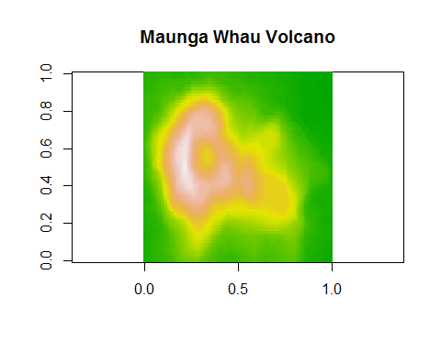

# test runmin, runmax and runmed  
 k=25; n=200;  
 x = rnorm(n,sd=30) + abs(seq(n)-n/4)  
 col = c("black", "red", "green", "brown", "blue", "magenta", "cyan")  
 plot(x, col=col[1], main = "Moving Window Analysis Functions (window size=25)")  
 lines(runmin (x,k), col=col[2])  
 lines(runmed (x,k), col=col[3])  
 lines(runmean(x,k), col=col[4])  
 lines(runmax (x,k), col=col[5])  
 legend(0,.9*n, c("data", "runmin", "runmed", "runmean", "runmax"), col=col, lty=1 )

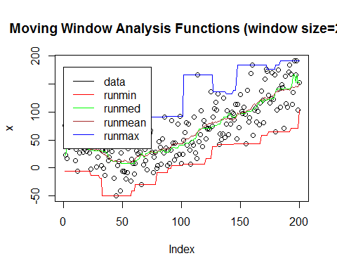

# sum vs. sumexact  
 x = c(1, 1e20, 1e40, -1e40, -1e20, -1)  
 a = sum(x); print(a)

## [1] -1e+20

b = sumexact(x); print(b)

## [1] 0

# Scope

1. Simulate everything from start
2. We will start with very simple model of mice CR data as the base data and augmentation 5 ,10 ,100 ,500 ,1000 zeros to the longest line of captures.
3. And then we will augmentation the same numbers of zeros but even independent of the number of captures in the trip.
4. Modify p
5. Use observed CR data and augment across same range

# Methods

## Key words

|  |  |
| --- | --- |
| Difference-discrete | Differential-continious |
| ecology | ecology |
| numerical response | lokta-volterra model |
| predator-prey | numerical response |
| mice dynamics | predator-prey |
| population dynamics | mice dynamics |
| difference equations | population dynamics |
| NA | differential equations |

### Additional options

alpha-hypothesis; age at maturity; arvicoline rodents; cycles; demographic mechanisms; fluctuate cyclically; mammals; population;

## Search patterns

Search APIs and pull out all matching keywords ranked from highest combined total to lowest. Databases searched will be:

*Scopus* Web of Science *Google Scholar* UC

# The data

The dataset consists of high quality capture-recapture (CR) data of mice, rats and kiore. Additional information on beech seed dynamics and the presence and absence of stoats is also used. Below we simulate the range of numerical and functonal responses tested.

# Results

## Key references: Introduced/invasive predators

### Choquent and Ruscoe 2000

$$r_{t} = a+bX_{t}+cSeed_{t}+dRat_{t}+σZ_{t}$$

Which is equivalent to the following:

$$r_{mice} =β_{0}+β_{1}(Seed)+β_{2}(Density)+β_{3}(Rats)$$

### Ruscoe et al. 2005

$$r_{mice} =β_{0}+β_{1}(Seed)+β_{2}(Density)+β_{3}(Rats)$$

Mice can also respond to seed avaliblity in a number of ways. The following functional responses have been applied to mice dynamics in NZ forests previously:

### Holland et al. 2015

### Ruscoe et al. 2005

# Functional responses

|  |  |  |  |
| --- | --- | --- | --- |
| Model_number | Equation | Parameter | Description |
| 1 | F1 | v | Type one linear response |
| 2 | F2 | v, r | Log difference |
| 3 | F3 | v | Ivlev equation |
| 4 | F4 | v | Type 3 |

$$F_{1}=S_{i}×c_{1}$$

$$F_{2}=S_{i}×ln(c_{1})$$

$$F_{3}<-S*(1- exp[a*(T_{i}*IR-T)])$$

In Ruscoe et al. 2005 this equation fitted the data best:

$$IR_{i}<-1042.1*(1- exp(-(beech.seed_{i}*0.00139)))$$

# Model simulations

## [,1]  
## [1,] 0.00000  
## [2,] 0.00139  
## [3,] 0.00278  
## [4,] 0.00417  
## [5,] 0.00556  
## [6,] 0.00695



$$IR_{i}<-S*(1- exp[a*(T_{i}*IR-T)])$$

Roger’s 1972 random predator equation

$$IR_{i}<-S*(1- exp[0.183*(0.00089*IR_{i}-24)])$$

# Numerical responses

## N1 $r_{mice} =β_{0}$

Intercept only model.

## N2 $r_{mice} =β_{0}+β_{1}(Seed)$

Seed driven dynamics.

## N3 $r_{mice} =β_{0}+β_{1}(Seed)+β_{2}(Density)$

Seed and density dependant effects.

## N4 $r_{mice} =β_{0}+β_{1}(Seed)+β_{2}(Density)+β_{3}(Rats)$ Seed driven, density limited and competition (rats).

# Discussion

# References

# Appendix